NS3 installation in Linux Mint 17 64 bit

Steps to install the ns3 version in Linux Mint 17 (64 bit):

Preliminaries
The following development libraries are to be installed before trying ns3
$prompt] sudo apt-get update
$prompt] sudo apt-get install build-essential autoconf automake libxmu-dev
$prompt] sudo apt-get install ia32-libs
(the above software ia32-libs is needed only when you want to run the 32 bit applications inside a 64 bit OS)
Now download the ns3 software from the website http://www.nsnam.org

Preferably download the version 3.20 (ns-allinone-3.20.tar.bz2).

Here is the installation steps of ns3
1. copy the ns-allinone-3.20.tar.bz2 in the home directory(Ex: /home/amrit)
2. Set the following path information (type these commands one by one in the terminal or copy these lines in the /home/amrit/.profile)
export BAKE_HOME=`pwd`/bake
export PATH=$PATH:$BAKE_HOME
export PYTHONPATH=$PYTHONPATH:$BAKE_HOME
3. Open the terminal and issue this command one by one
$prompt] tar jxvf ns-allinone-3.20.tar.gz
$prompt] cd ns-allinone-3.30.1/
$prompt] cd bake
$prompt] ./bake.py configure -e ns-3.30.1
$prompt] ./bake check
(This step will tell you the extra software that needs to be installed)
$prompt] ./bake download (download the software)
$prompt] sudo apt-get install python-pygoocanvas python-pygraphviz python-dev qt4-default p7zip-full bzr cmake mercurial git cvs
See the screenshot after the command ./bake.py check
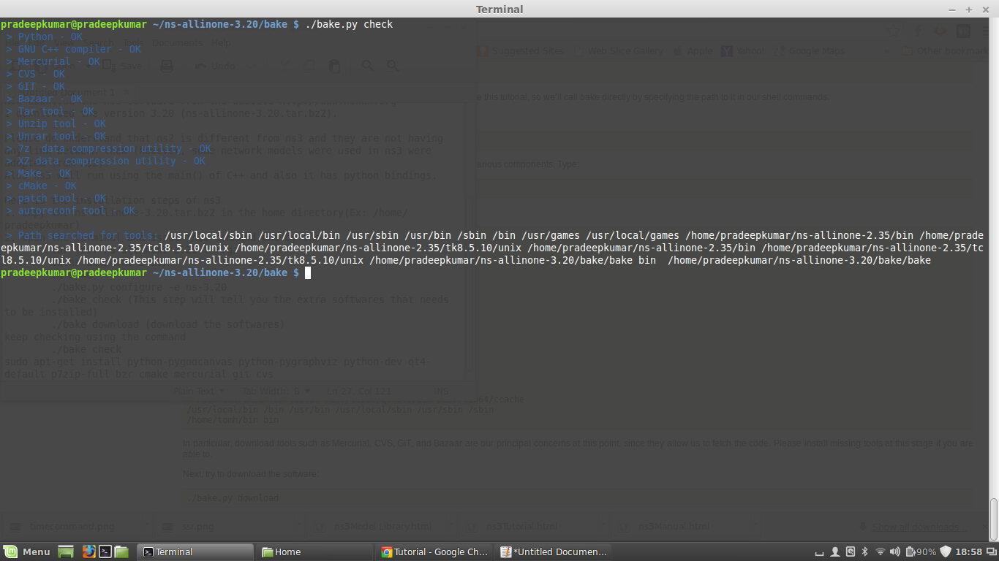
bake.py check

see the screenshot after the command ./bake.py download
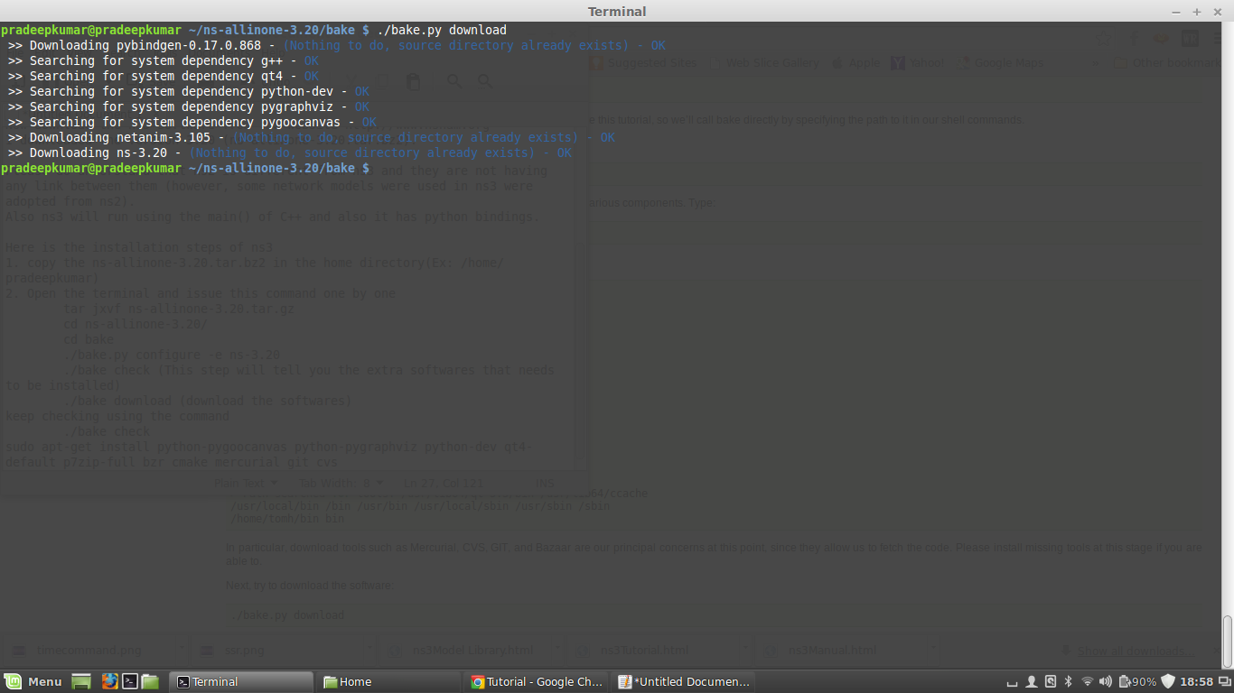
bake.py download
The above command will install the optional files that may need to run ns3 completely. And here is the complete build of ns3
$prompt] ./build.py --enable-examples --enable-tests
See the screenshot below for information
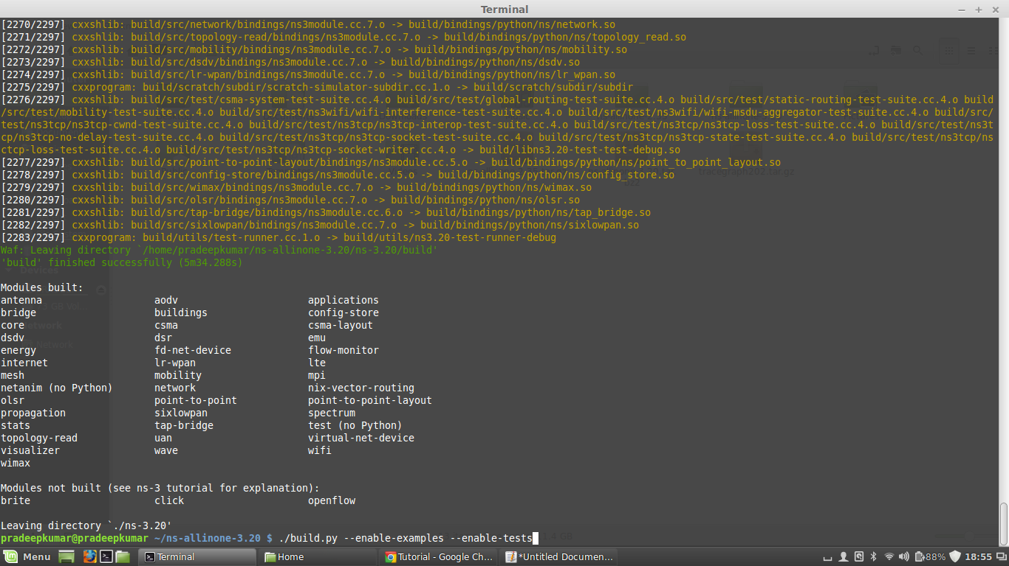
ns3 installation

